Coursera Neural Nets Course

Lecture 2
Normal NN’s have straightforward feed forward architecture, RNN’s have loops and so can remember information, and exhibit oscillations, but more difficult to train due to increased complexity (also more biologically accurate). Symmetrically connected – weights are the same forward and backward. Much easier to analyse then RNNs mainly because they are more restricted since based on an energy function
RNNs good for sequential data

When we learn, we try to determine the probability that a feature contributes to the output we want to generate.
“Learn how to weight each of the feature activations to get a single scalar quantity”, the weights represent how much evidence the feature gives u in favor or against the hypothesis that the current input is an example of the kind of pattern u want to recognise. When we add up we get scalar quantity and if it crosses threshold we think it satisfies hypothesis

First example of perceptron trained to classify trucks and tanks, but all trucks images taken on sunny day and algo picked up total intensity rather than anything else

For NN have weights and threshold, threshold is equivalent to negative bias, to avoid having 2 rules we treat bias as a weight on an extra input line that has activity of 1, can then learn bias as a weight.

Y = b + sum(w*x) linear neuron
Binary threshold, uses step functions

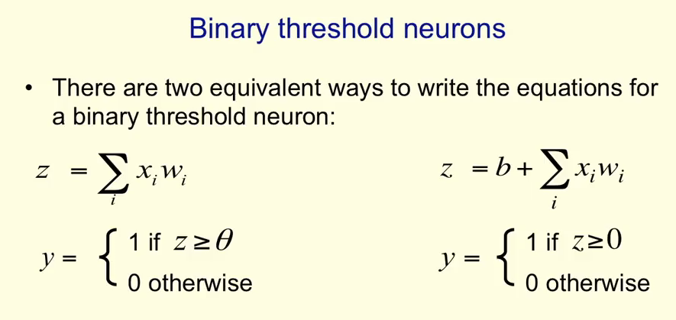
theta = -b

Rectified Linear Neurons
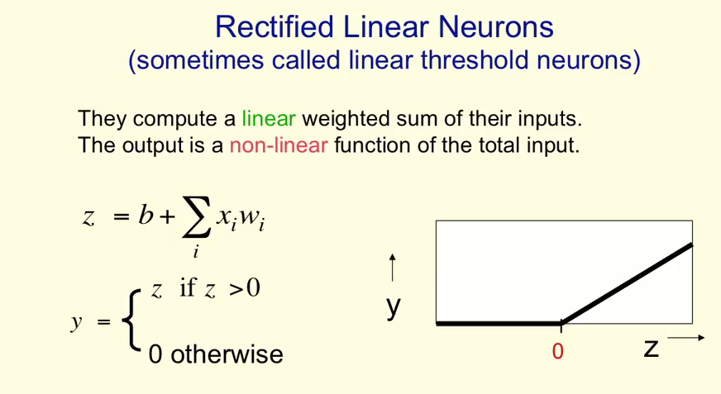
Above zero is linear but is 0 below
get nice linear properties above zero but also ability to make decision

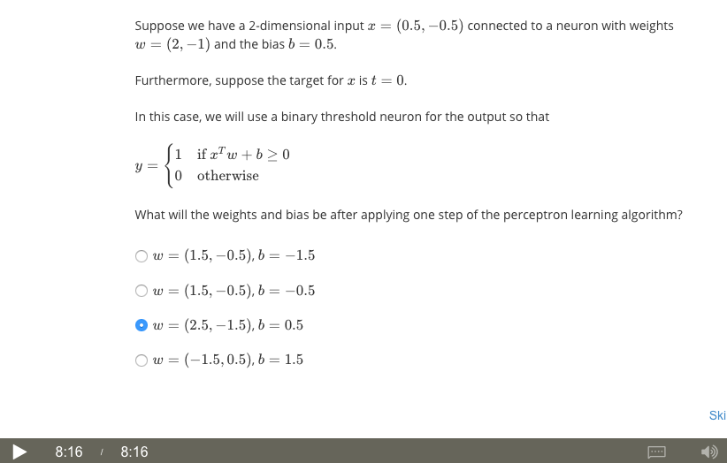

Sigmoid
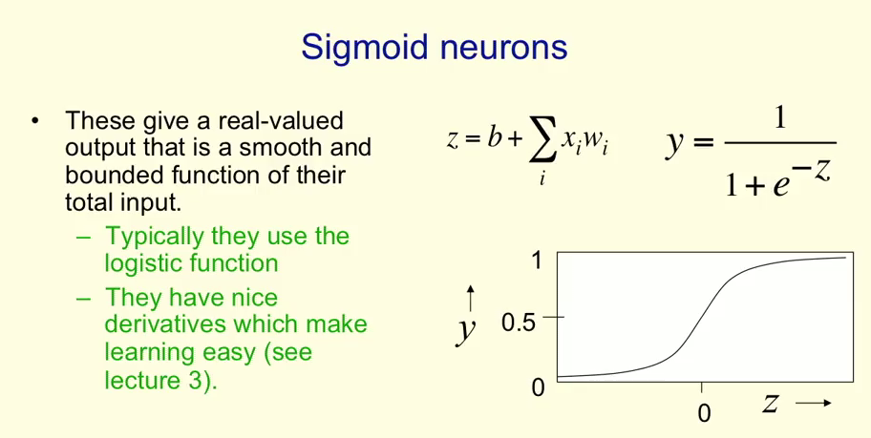

We test with xtw + b and if the condition is met ie y=1, we do nothing, if it fails, subtract the input vector from the weight vector if output incorrectly predicts a 1, and add the input vector to the weight vector if output incorrectly predicts a 0.
To take account of the bias, we add a 1 to the input vector, forming homogeneous form.
Guaranteed to find weights IF THEY EXIST. Need to find the right features to allow this

Stochastic
Use same logistic function but then use the output as input to a probabilistic function that ouputs 1 or 0, so introduces some randomness

Increment weights from active pixels to correct class, decrement weights from active pixels to whatever class netweork guesses, if it guess corrrect, there will be no change but wrong ones will decline

Deeper networks give greater abstraction of the learned features

Geometrical View of Perceptrons
Weight space – has 1 dimension for each weight in the perepron. Point in this space corresponds to 1 seting of weights.
If we eliminate threshold each training case can be represented as a hyperplane through the origin- the weights must lie on one side of this hyperplane to get the answer correct

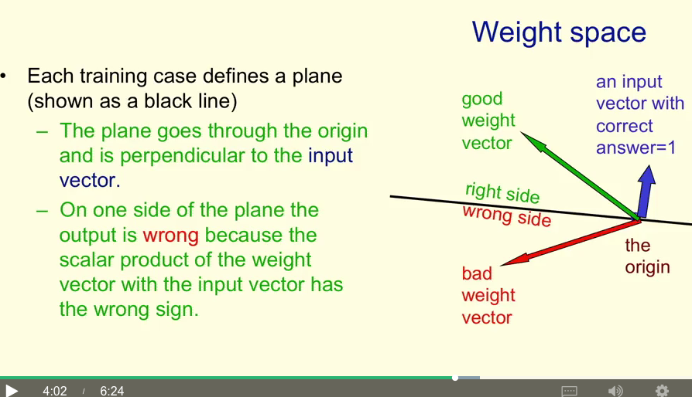
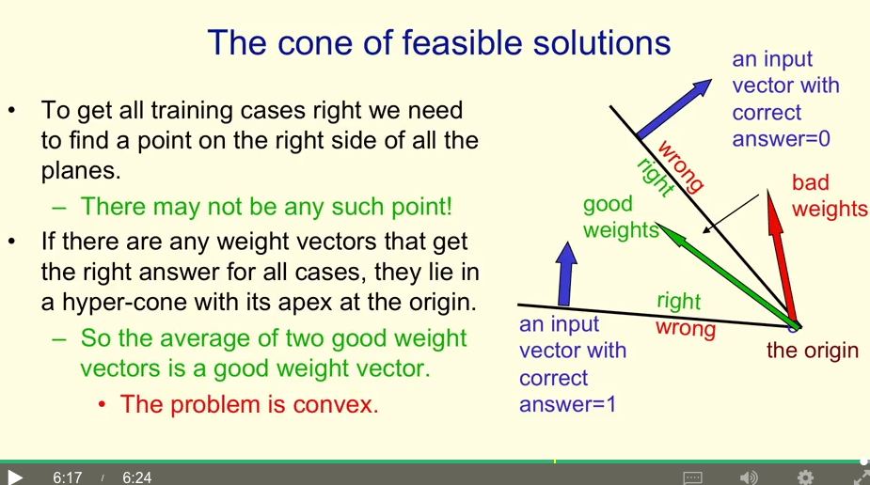

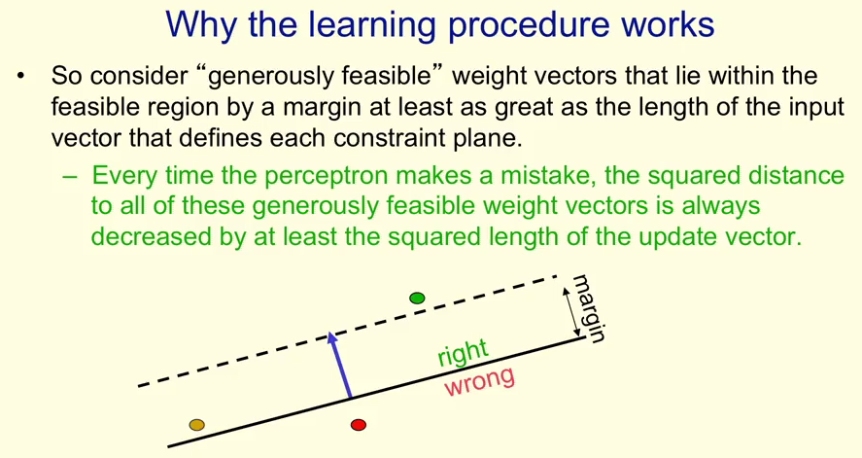
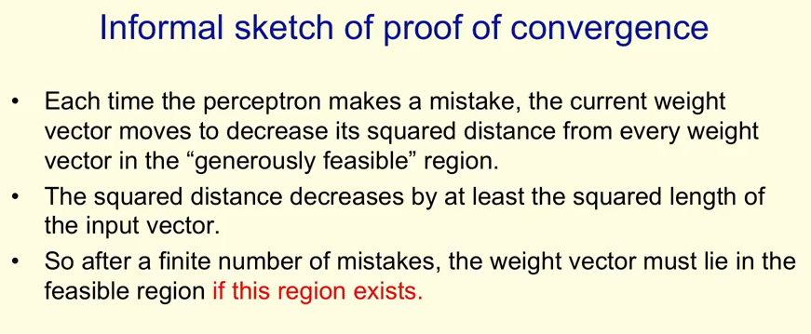
Binary threshold neurons cant deal with nonlinearly separable data. They also cant discriminate between patterns that are similar but occur in different places (translate with wrap around)

perceptrons cant learn transformations that form a group

Lecture 3
Linear neurons - real valued ouput which is weighted sum on inputs y = wtranspose*x

Use iterative learning procedure by updating the weights so that they come closer to the target.
The weights take a long time to converge if they are highly correlated, since hard to decide which feature is responsible for changes in the ouput

delta rule like perceptron learning but we have to choose learning rate ourselves which can be hard

For linear neuron with squared error we get this error surface
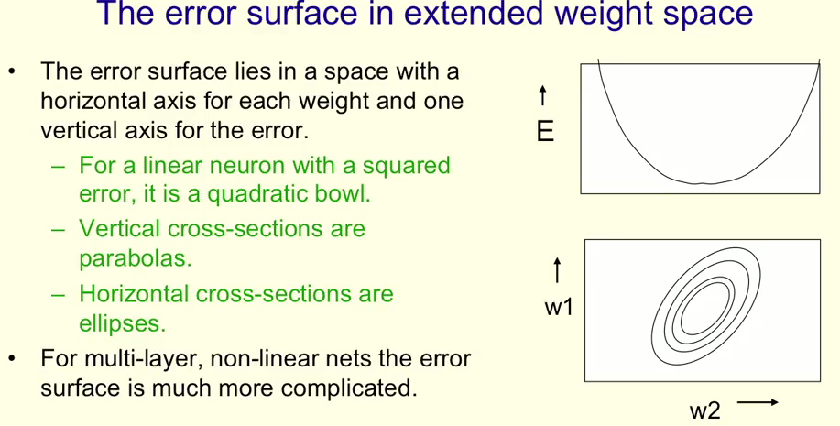
Different for higher dimension, more complicated error functions

0.5(w1 – w2 – 0)^2 + 0.5(w2 – 1)^2
0.5(w1^2 + w2^2 -2w1w2) + 0.5(w2^2 -2w2 +1)
0.5(w1^2 +2 w2^2 -2w1w2 -2w2 +1)

Online vs batch learning
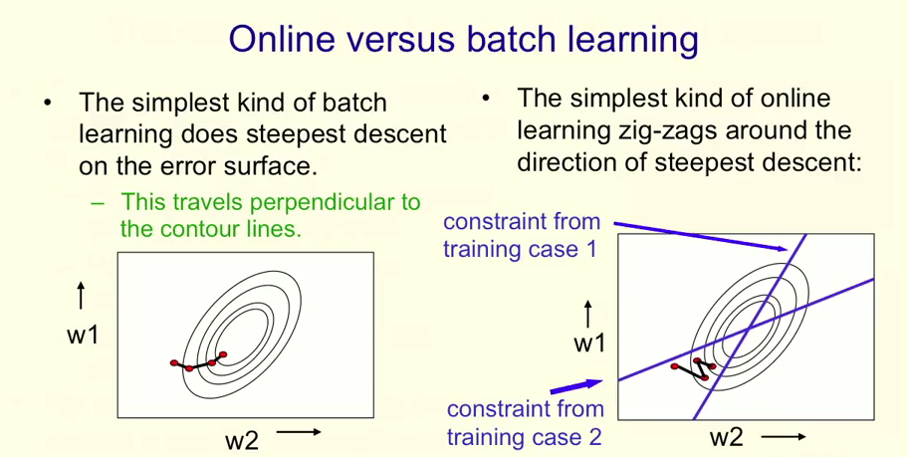
Online (change after each training case) zigzags around error parabola whil batch is more direct

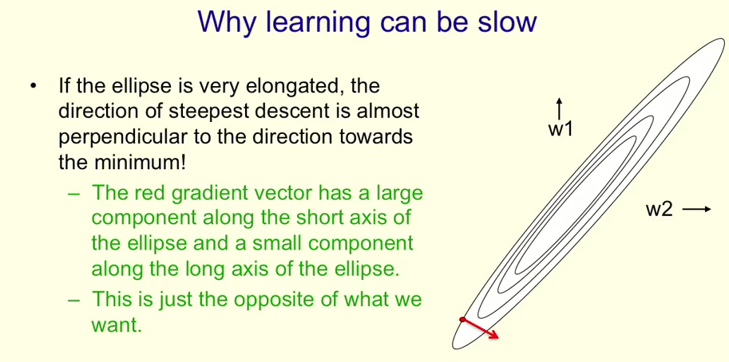
If the features are highly correlated, descent will be slow because of the direction of the gradient. The important point is the diagonal nature of ellipse across the features, an ellipse centred on an axis can proceed along the axis as if it is 1d

From Linear to Logistic(aka logit) (nonlinear) neurons
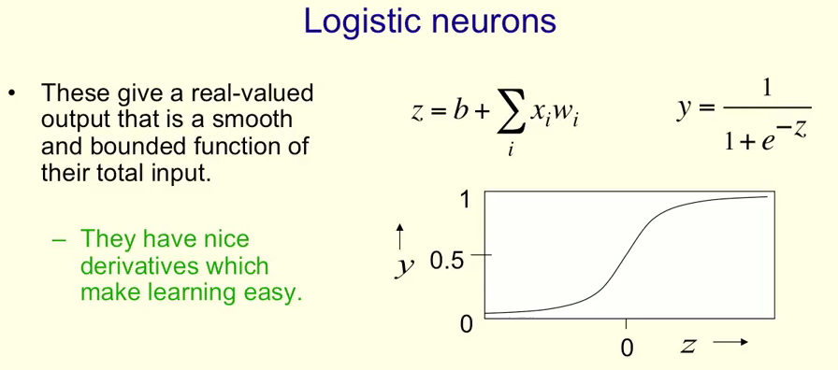
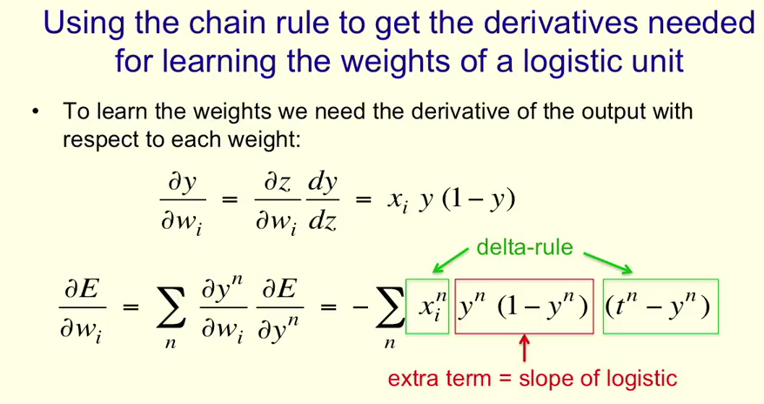
The Backpropogation Algorithm
Could us perturbation but not good.
For back propogation, after we have done the forward pass to learn some weights, at the output layer, we then want to learn the weights of the hidden layers. This can be done with some nice calculus. We learn how the error changes as the weights on the connections changes when we sum over all the layers

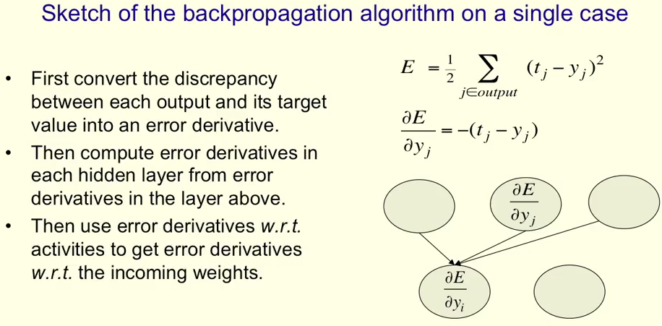
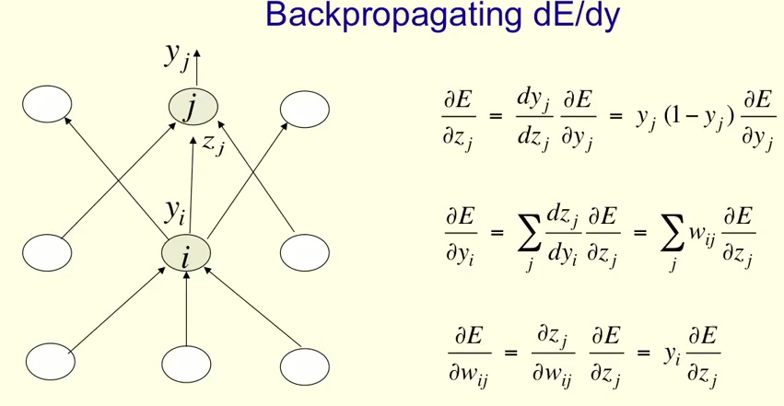

With this knowledge, we still have to determine how we:
1. optimise, so how do we use the error derivatives on individual cases to discover a good set of weights
2. Generalise, how do we ensure that the learned weights work well for cases unseen in training

Optimisation issues
How often to update: Online(for each training case), Full batch (after a full sweep of the training data, adding together all the derivatives and then move small step in deriv direction. Problem is it is expensive and too much data. Minibatch, we use a subset, gives us best of both world
How much to update: Fixed learning rate? Adapt global learning rate? Adapt learning rate for each weight on network? Dont use steepest descent (not always the best direction, especially near end of learning or for correlated features)?

